Cloud Service Selection Using
Machine Learning

Prasad Manchanayaka (1st Author)
Software Engineering Teaching Unit
University of Kelaniya
Horana, Sri Lanka
shalikamanchanayaka38@gmail.com
line 1: Firstname Surname (2nd Author)
line 2: Department Name
(of the University / Institute)
line 3: Name of the University
or Institute (of Affiliation)
line 4: City, Country
line 5: email address

Abstract — Cloud computing (CC) has recently been receiving tremendous attention from the IT trade and educational researchers. CC leverages its distinctive services to cloud customers in a very pay-as-you-go, anytime and anyplace manner. As well as Cloud services offer dynamically scalable services on demand. Therefore, service supplying plays a key role in CC. Then, it is good opportunity for customers to find suitable and lowly cost service for their project. Specially, Customer must be able to select appropriate cloud service according to their needs and money. It is time-consuming task for consumers to collect the necessary information and analyze from all cloud service providers to make right decision. As well as it is also a highly demanding task from a computational perspective because multiple consumers who have similar requirements conduct same computations repeatedly. We use Support Vector Machine (SVM), Multiple linear regression (MLR) and Multiple-criteria decision analysis (MCDA). We develop efficient and flexible recommendation system for ranking cloud service providers. I prove accuracy and effectiveness of our approach through an experimental study with the real and synthetic Cloud data.
Keywords — CC, SVM, MCDA, MLR

Introduction
They provide all products you might need for moving your business to the cloud. But these product offerings differ in pricing as well as the naming of their services. Some Businessmen already may use on-premise infrastructure or think which infrastructure will use for my project. They may have more complex problems like how to choose a cloud service, which services want use and specially how many costs want to pay for monthly or yearly. Sometimes, someone already use a cloud services, they have lot of problems like more expensive, less flexibility, hard to use, overwhelming options of services, poor management of GUI and tool, complex price schema and other issues. However, they must spend more price and time as useless. Because they could not select best cloud service provider early to their business. As well as, if these company would move data from one cloud to another, that is elaborate time-consuming and expensive. Small companies or individuals do not have the software architect or experienced software engineers. Thus, some businesses may break, get low profits, and spend more costs without using all provided benefits too.
Therefore, a systematic solution will be developed to predict which cloud service use for your project powered by Artificial Intelligence. Predict which service provider is good, and cost prediction. In addition special thing is minimizing your cost according your web project type (Entry level workload, Micro-service application, Virtual Desktop, Database, Code Repository, Business-critical application, Gaming server, Interactive application, Web server, Build server, Testing) that will be given through the system and we highlight several services (Region, Compute, Storage, Database, Networking, Operation, Identity & Access and Pricing Model). You want to use for minimizing cost. The main end user of the system is data of these cloud service providers. As well as You can know which cost usage might be able to spend weekly, monthly or yearly according to web traffic for your projects. The other indirect end users are software architects, the employees of web development and expert web freelancers. We prove the effectiveness and efficiency of our approach with real and synthetic cloud data. Then describe what research question was addressed by the present study. Finally, a summary sentence would be required for the reader to understand how your attempts and results would contribute to the overall field of study.

OBJETIVES

Machine Learning has three types that we can select to predict result. According to this research, I used the Supervise learning. So, we should have past data sets with labels to learn and make future predictions. As well as, it has two parts. There are regression and classification type. Firstly, we want to identify projects that customer created. So, we can identify which type of project simply without using machine learning. It just wants user a requirement. After, we can use this for other Machine family type like these. We use Multiclass Classification with Support Vector Machines (SVM) to recognize to instance type for customer project. Next, we want to select Regression type as we want numeric values like price, sizes of vm, size of ram like that. As well as we want to classification type. Because, we have to select who is the best cloud provider from other cloud service providers. Regression has two parts, then we use Multiple linear regression. because, we have multiple variables as X like Location, Instance Family, Storage, Network Performance, Operating System, Current Generation, Tenancy, Offering Class, Purchase Option, Lease Contract Length, and etc. After the calculate result for prices, we want to select which cloud provider is good according to result and user requirements. I could find dataset of AWS EC2 for prediction algorithm [8]. Then, I hope to use MCDA method, because lack of dataset about user feedbacks. MCDA is the good method to solve these type of problems [3]. Other thing is that it is directly depend on user preference(weight) for these criteria.

METHODOLOGY
According to diagrams, I decide to divide some sections for identifying Virtual Machine. Firstly, we want to identify projects that customer created. So, we can identify which type of project generally. For that,
Required Very Low Infrastructure => Micro
Required Quick Response => General Purpose
Required High Processing Power => Compute-optimized
Required High Memory Usage => Memory-optimized
Required High Graphical Processing Power => GPU-optimized
Required High Storage Capacity => Storage-optimized
After identify type of project generally, we want to identify as advanced. For that, I want to more details like project type, performance, size of project (E.g.: small database, high performance large business critical application, low latency interactive application), memory size, vCPUs and other factors. After, we identify about customer project, we can find which Instance type is suitable for their project. We can use this for other Machine family type like these. We use Multiclass Classification with Support Vector Machines (SVM) to recognize to instance type for customer project.

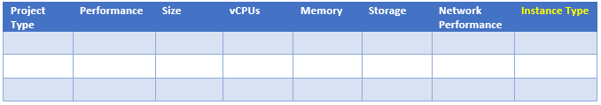
Let’s see, if customer project is under General purpose family. Customer can set value according their experience in local environment.
- Instance Type = [AWS_A1, AWS_T4g, AWS_T3, AWS_T3a, AWS_T2, AWS_M6g, AWS_M5, AWS_M5a, AWS_M5n, AWS_M4]
- Project Type = [Entry level workload, Micro-service application, Virtual Desktop, Database, Code Repository, Business-critical application, Gaming server, Interactive application, Web server, Build server, Testing]
- Performance = [low, medium, high]
- Size = [small, medium, large]
- Memory = [(1-2), (2-4), (4-8), (8-16), (16-32), (32-64), (64-96), (96-128), (128-256), (256-384)]
- vCPUs = [(1-2), (2-4), (4-8), (8-10), (12-16), (16-24), (24-32), (32-48), (48-64), (64-72), (72-96)]
- Storage= [EBS, SSD]
- Network Performance = [Low, Up to 10, Low to Moderate, Moderate, Up to 25, High]
After, we identify instance type of virtual machine, we can predict price for that machine.
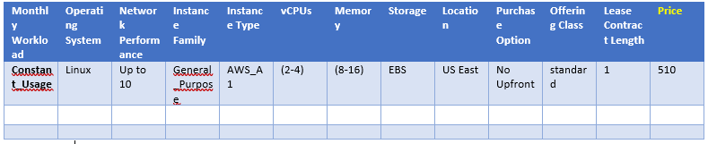
- Monthly_Workload = [Constant_Usage, Daily_Spike_Traffic, Weekly_Spike_Traffic, Monthly_Spike_Traffic]
- Operating_System = [Windows, Linux, RHEL, SUSE]
- Network_Performance = [Low, Up to 10, Low to Moderate, Moderate, Up to 25, High]
- Instance_Family = [General_Purpose, Compute_Optimized, Memory_Optimized, Accelerated_Computing, Storage_Optimized]
- Instance_Type = [AWS_A1, AWS_T4g, AWS_T3, AWS_T3a, AWS_T2, AWS_M6g, AWS_M5, AWS_M5a, AWS_M5n, AWS_M4]
- Memory = [(1-2), (2-4), (4-8), (8-16), (16-32), (32-64), (64-96), (96-128), (128-256), (256-384)]
- vCPUs = [(1-2), (2-4), (4-8), (8-10), (12-16), (16-24), (24-32), (32-48), (48-64), (64-72), (72-96)]
- Storage= [EBS, SSD]
- Location = [US East, US West, Asia Pacific, Canada, South America]
- Purchase_Option = [No Upfront, Partial Upfront, All Upfront]
- Offering_Class = [standard, convertible]
- Lease_Contract_Length = [1, 3]
I hope to use Multiple linear regression. because, we have multiple variables like Location, Instance Family, Storage, Network. It can use all other service providers like this method.
Then, I hope to use (Multiple-criteria decision analysis) MCDA method, because lack of dataset about user feedbacks. MCDA is the good method to solve these types of problems. Other thing is that it is directly depend on user preference(weight) for these criteria.
Now, we have many factors after calculating Instance family (recommendation for project type), prices (predict cost according to the recommendation and other user requirement). So, Sometimes, Customer not only want low cost, but they may also have different external requirements. There are Familiarity (Windows user may like to Azure), Quality of Service, Security (AWS and Azure has more security features), Discount Rating (more discount rating available in GCP), Other Services (more services available in AWS), Availability (Some company can have Subscriptions that already purchased) like more non-functional requirements. We cannot drop these requirements, So, I hope to use MCDA method to decide final selection (who is the best provider) from these cloud service providers.

RESULTS AND DISCUSSION
This section should present your experimental data to the reader, which relates to your most important findings. These data should be supported with interpretation of the data, with relevant discussions. The data may be presented in tables and more preferably in figures.
Table 1. Categorization of items as an example
Item1 | Item2
Item1 | Item3 | Item4 | Item4
content | content | content | content

Figure captions should be below the figures; table heads should appear above the tables. Insert figures and tables after they are cited in the text. Titles and the contents in the tables and the figures should be typed in size 8, using the font ‘Times New Roman’.
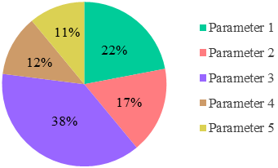
You may also use a text box to insert a graphic (in high resolution: 300 dpi TIFF or EPS file, with all fonts embedded) when inserting a picture. Text box should not contain any fill colour, border, shadow, etc.

Fig. 1. Example of a presentation of data in a pie chart
In the text, you may refer these figures and tables as Fig. 1, and Table 1.
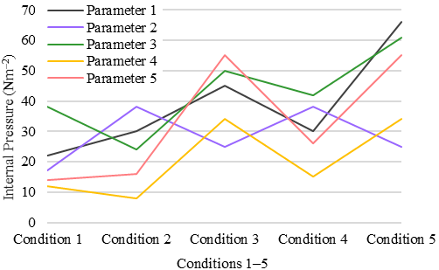
Fig. 2. Example of a presentation of a chart with proper axis labels and units
You may get some important practical tips for writing your paper in this reference [1].

CONCLUSION
In this section, briefly describe your research work again, and then state the major results in summary. You may also highlight the major points of the discussion, which relates to your most important findings. You can end this section with a statement of how your findings contributes to the overall field of study.

References

[1] S. Taylor, A. Young, and J. Macaulay. Small businesses ride the cloud: Smb cloud watch - U.S. survey results.
[2] S. K. Garg, S. Versteeg, and R. Buyya, “A framework for ranking of cloud computing services,” Future Generation Computer Systems, vol. 29, no. 4, pp. 1012–1023, 2013
[3] J. Figueira, S. Greco, and M. Ehrgott, Multiple Criteria Decision Analysis: State of the Art Surveys, vol. 78, Springer, 2005.
[4] Z. ur Rehman, O. K. Hussain, and F. K. Hussain, “Iaas cloud selection using MCDM methods,” in Proceedings of the 19th IEEE International Conference on e-Business Engineering (ICEBE ’12), pp. 246–251, 2012
[5] Smitha Sundareswaran; Anna Squicciarini; Dan Lin 2012 IEEE Fifth International Conference on Cloud Computing Year: 2012.
[6] Agata Nawrocka ; Andrzej Kot ; Marcin Nawrocki 2018 19th International Carpathian Control Conference (ICCC) Year: 2018.
[7] S K Pushpa ; T N Manjunath ; T V Mrunal ; Amartya Singh ; C Suhas 2017 International Conference On Smart Technologies For Smart Nation
(SmartTechCon) Year: 2017
[8] https://www.kaggle.com/akashsarda/aws-ec2-pricing-data

